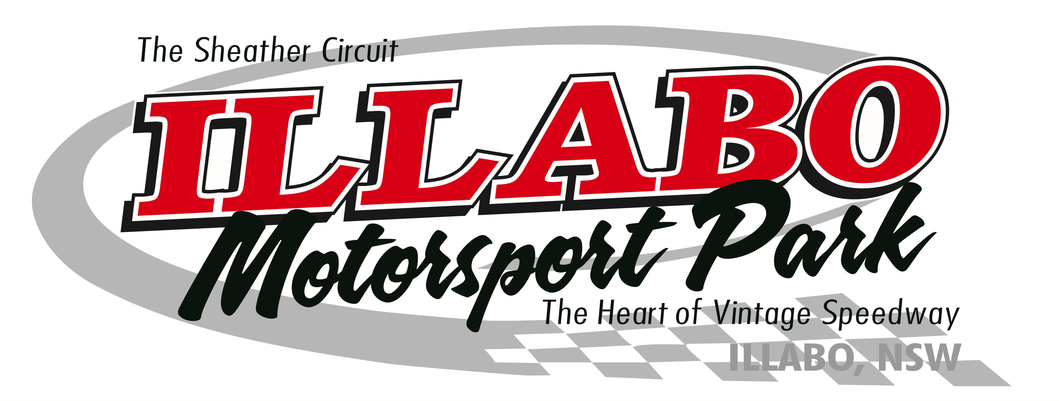
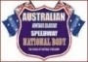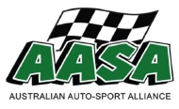 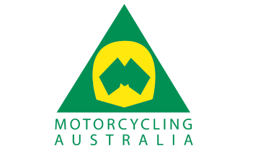 Vintage Speedway Event Calendar 2019.
*Saturday 9th &* Sunday 10th March 2019
The Shannon’s Vintage Classic Speedway meeting.
**2 Day Vintage Spectacular Speedway Meeting**Coincides with Junee Rhythm & Rail Festival weekend
*Saturday 9th March Motorcycle Australia Permit organised Vintage Solo & Sidecar Come & Try Event
*Saturday 9th March AASA Permit Speedway Kart “Come & Try “Event
Sunday 10thMarch Speedway Australia Permit Event for Vintage Speedcars
All Vintage Speedcar/Modified/Sprintcars
Saturday 4th May 2019
The Gordon Benny Tribute Vintage Speedway Meeting
Saturday 17th Sunday 18th August 2019
**2 Day Vintage Spectacular Speedway Meeting
*Saturday 17th August Motorcycle Australia Permit organised Vintage Solo & Sidecar Come & Try Event, also a AASA Permit Speedway Kart “Come & Try” Events
Sunday 18th August: All Vintage Speedcar categories on Sunday includes
The Tribute to Peter Bowland & Bob Pymble
Saturday 19th October 2019.
The Vintage Classic Meeting: All Vintage Speedcar/Modified/Sprintcars

The incorporated entity to administer Illabo Motorsport Park events

Proudly Supported by
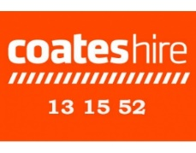

Website: www.gw.org.au https://www.facebook.com/IllaboMSP/

